

[Date]

Lab Report on

One dimensional array

**Course Title:** Structured Programming Language Lab

**Course Code:** CSE 112

**Date of Submission: 12.12.18**

**Submitted by:**

**Name :** Syeda Nowshin Ibnat

**ID :** 17183103020

**Intake :** 39

**Section :** 01

**Program :** B.Sc. in CSE

**Submitted to:**

**Name:** Md. Hasibur Rahman

Lecturer,Dept. of CSE at

Bangladesh University of Business and Technology.

Lab-7(Array)

**Prog-1**

**Title:** A C program to find the second largest element of an array.

**Source Code:**

#include<stdio.h>

int main()

{

int a[6]={6,10,15,3,20,4};

int i, max1=0, max2=0;

for(i=0 ; i<6 ; i++)

{

if(a[i] > max1)

max1 = a[i]; }

for(i=0 ; i<5 ; i++)

{

if(max1 != a[i])

{

if(max2 <= a[i])

max2 = a[i];

}

}

printf("Second largest element : %d\n",max2);

return 0;

}

**Output:**

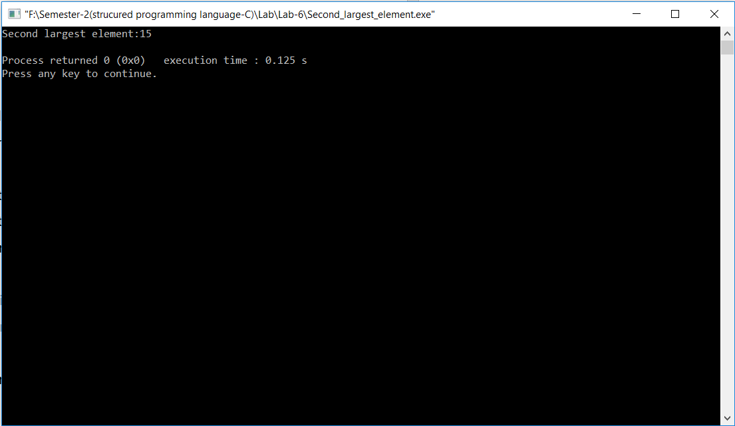

**//2)Find the Average of odd elements of an array.**

#include <stdio.h>

int main()

{

int a[7]={3,2,4,13.7,16.8,10,55};

int i, n=7, count=0;

float sum=0, average;

for (i=0 ; i<n ; i++)

{

if(a[i]%2 == 1)

{

count++;

sum= sum + a[i];

}

}

average = sum/count;

printf ("Average is:%.2f",average);

return 0;

}

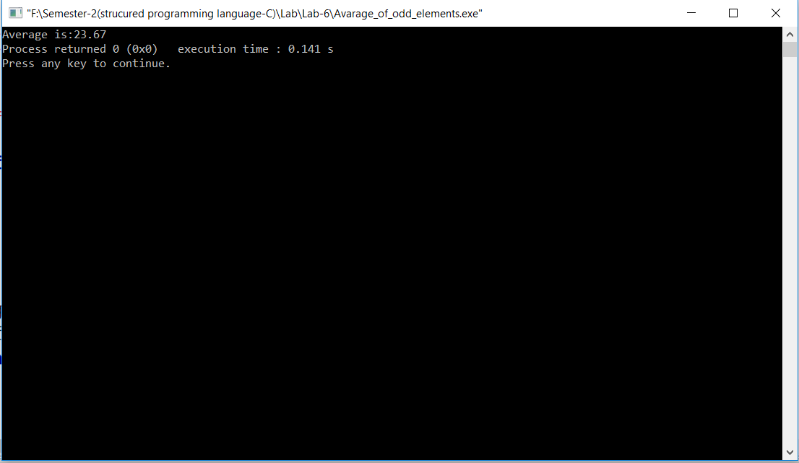

**//3)Find the frequency of an array.**

#include <stdio.h>

int main()

{

int a[50], freq[50];

int n, i, j, count;

printf("Enter size of array: ");

scanf("%d",&n);

printf("Enter elements in array: ");

for(i=0 ; i<n ; i++)

{

scanf("%d", &a[i]);

freq[i] = -1;

}

for(i=0 ; i<n ; i++)

{

count = 1;

for(j=i+1 ; j<n ; j++)

{

if(a[i]==a[j] {

count++;

freq[j] = 0;

}

}

if(freq[i] != 0)

{

freq[i] = count;

}

}

printf("\nFrequency of all elements of array : \n");

for(i=0 ; i<n ; i++)

{

if(freq[i] != 0)

{

printf("%d occurs %d times\n", a[i], freq[i]);

}

}

return 0;

}

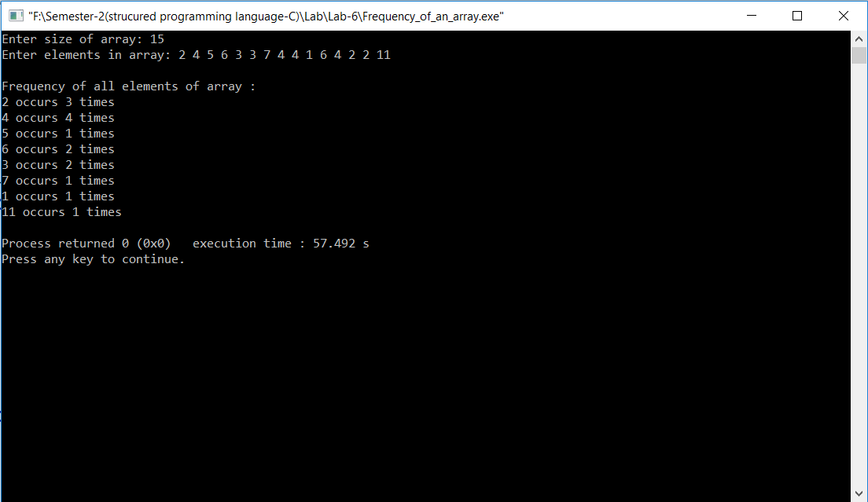

**//4)Copy the elements of an array in reverse order.**

#include <stdio.h>

int main()

{

int a[10]= {1,2,3,4,5,6,7,8,9,10},b[10];

int i, temp, n=10;

for (temp=0,i=n-1; i>=0; temp++,i--)

{

b[temp]=a[i];

}

printf("Reverse array:");

for(i=0; i<n; i++)

{

printf("\n%d",b[i]);

}

return 0;

}

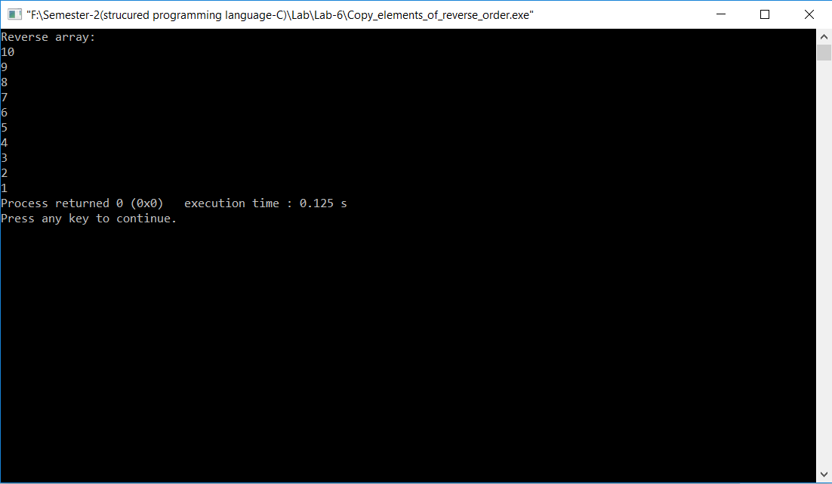

**//5)Find the square root of the elements of an array**.

#include<stdio.h>

#include<math.h>

int main()

{

int a[6]={4,9,13,25,100,308};

int i,n=6;

float b[6];

for(i=0;i<n;i++)

{

b[i]=sqrt(a[i]);

}

printf("square root of the elements:");

for(i=0;i<n;i++)

{

printf("\n%.1f",b[i]);

}

return 0;

}

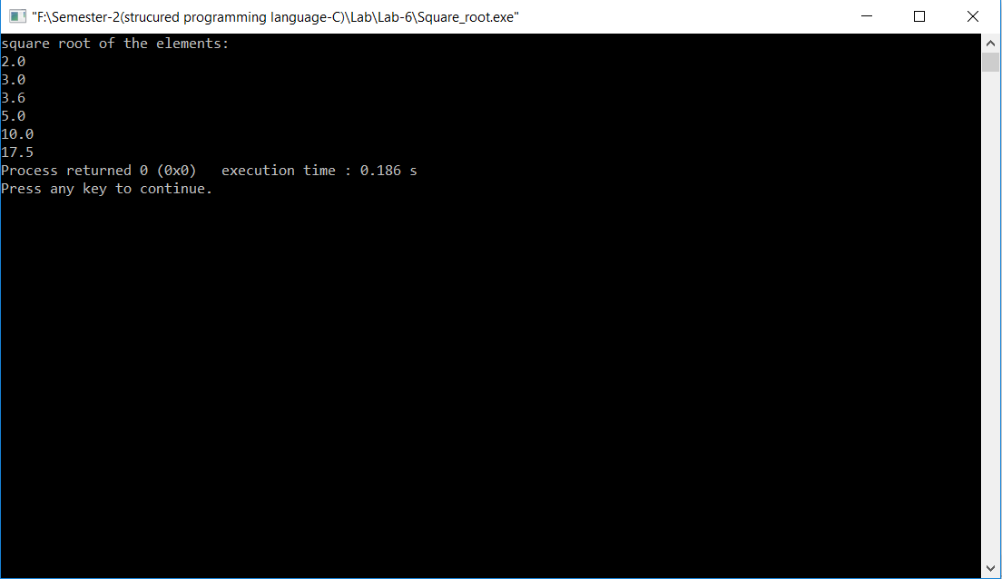

**//6)Find the difference (absolute value) and summation of an array.**

#include<stdio.h>

int main()

{

int a[50]={5,4,3,2,1,6,2},b[50];

int i,j,sum=0;

for(i=0,j=1;i<7 && j<8;i++,j++)

{

b[i]=abs(a[i]-a[j]);

}

printf("Difference: ");

for(i=0;i<6;i++)

{

printf("%d ",b[i]);

sum=sum+b[i]; }

printf("\n");

printf("\nThe summation is:%d\n",sum);

return 0;

}

